**Chameleon Ball**

**By**

Date: 28/06/2017

Contents

Version Information 3

Introduction 4

|  |  |  |
| --- | --- | --- |
| Target Audience: Fun game players  Target Platform: PC  Genre: Puzzle  Number of Player: 1  Project Release Date: 30/06/2017 | | |
| Modifying Date | Name | Content |
| 28/06/2017 | Viktor | Introduction, level design |

Version Information

Introduction

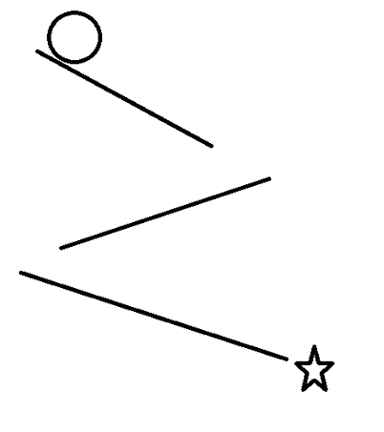It’s a 2D puzzle game just like the right picture, the ball will slide from the top into the bottom because of gravity, but it will be destroyed if it go to areas which is different from its color. Players should use the items of the scene to change the ball’s color or areas’ color in order to make the ball arrive in the destination.

Game Structure

**Control**

The players use the mouse to click items in the scene to change the ball’s color or areas’ color.

**Rule**

When the balls go to areas which is different from ball’s color, the ball will be destroyed. When the balls go to the destination, players win.

Level Design

**Level 1**

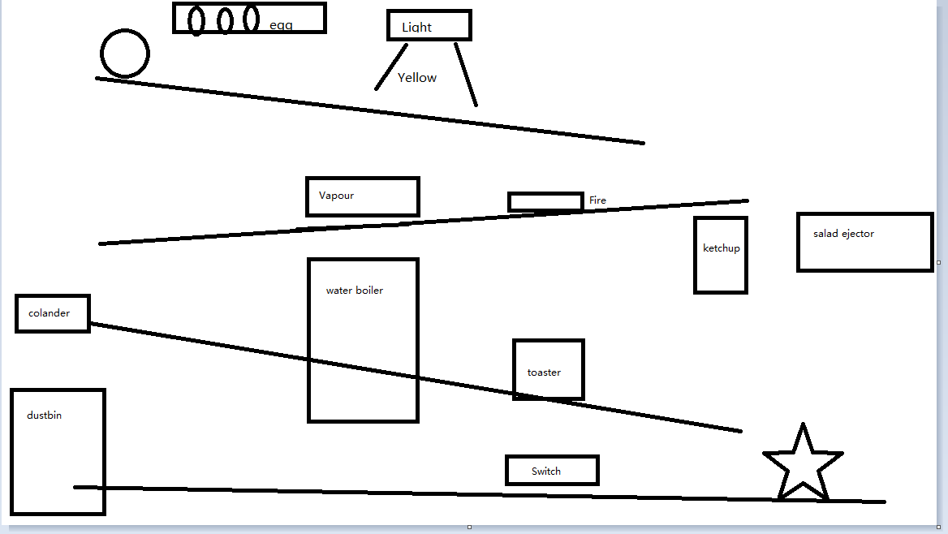

|  |  |
| --- | --- |
| **Content** | **Function** |
| Egg | Click then break to change ball into yellow |
| Light | Click to change the light color to create two color area – red or yellow |
| Salad ejector | Click then eject salad to change ball into white |
| Ketchup | Click then squeeze to change ball into red |
| Fire | Create red area |
| Water boiler | Create white area |
| Colander | When ball cross, it is split into two balls |
| Dustbin | Click then producing dust to change the ball into black |
| Toaster | When ball arrive, it will be trapped in |
| Switch | Create black area, if the ball cross and the ball is black, it will make toaster pop another ball. |
| Star | When the two balls arrive, win |